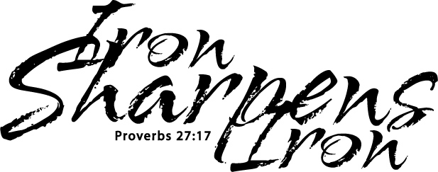

Here are some ideas for communicating with the women of your church through church bulletins and email blasts:

Example #1

Attention Women! We will be attending the Women’s Iron Sharpens Iron Conference on November 2nd as a group. Please sign up today and join us! This one-day conference is for women of all ages, beginning with women age 13 and older. The early group registration cost is only $57($40 for students), which includes lunch. There will be sixteen different seminars for women at this conference so we know there will be something for every one of us. Please sign-up after the service.

Example #2

Attention Women! The Women’s Iron Sharpens Iron Conference is coming to Moline, IL and we will be taking as many women as we can to this unique event. The early group registration cost is only $57($40 for students), which includes lunch. See the women at the table (in the foyer) after the service for more information. Join us for a great day on Saturday, November 2nd.

